**What was already known & Latest Findings about the topic concerned:**

# Coronavirus outbreak predicted to have an impact on financial markets and the global economy

According to an online survey conducted between February 14 and 15th in nine large countries, Japan is the mostly likely to agree that the coronavirus outbreak will have an impact on the financial markets and the global economy (84% agree), followed by Australia (80%), Italy (78%), Russia (76%), Canada (76%) and France (73%). While still a majority, citizens of the United States (62%) and the United Kingdom (60%) were less likely to agree.

An analysis of the demographic profiles by country suggests that those in the higher income brackets are more likely to agree that the virus will have an impact on the financial markets.

The survey was conducted in Australia, Canada, France, Germany, Italy, Japan, Russia, the United Kingdom and the United States.

Two in three citizens in Japan see the virus as a very high or high threat to the world (66%), followed by Italy (59%), Australia (57%), Germany (54%), France (52%) and the US (52%). While slightly below a majority in the UK (47%), Russia (46%) and Canada (42%) still perceive a high or very high threat to the world.

By contrast, the perceived level of individual threat remains stable or decreases slightly in all countries other than Japan, where one in four citizens see the virus as a very high or high threat for them personally (up 9 points from last week). Perception of personal threat is the lowest in France (7%) and in Canada (5%).

A majority in each of the countries surveyed believe the outbreak will not be contained any time soon. Less than one in ten believe the virus is contained now, while about seven in ten state that the outbreak will take several months or longer to contain. This view is highest in Japan with 88% indicating that containment will take several months or longer and lowest in Russia and the U.S.

**Social Distancing, Curfews, and the Current Local Economy**

Enforcing the necessary social distancing measures, and subsequently, curfews have effectively stalled the local economy. Whilst some economic activities that can be carried out remotely continue, particularly in the services sector, manufacturing and retail services have effectively come to a standstill. Moreover, even though the government has allowed agricultural production to continue unhindered, uncertainties surrounding temporary lifting of curfew hours and means of distributing essential goods to households result in wastage and a slowdown in the supply and storage of perishable agricultural goods.

The Government of Sri Lanka (GoSL) initiated several endeavors to help the country prevent, detect, and respond to the COVID-19 pandemic and strengthen its public health preparedness. Some key actions implemented include,

* Aggressive “social distancing” measures implemented in the entire country.
* Issuing travel bans to other affected countries and closing of ports and airports.
* Island wide strict curfews.
* Public-Private Partnerships to aid Sri Lankan households obtain emergency supplies
* Emergency health and economic measures, including several economic relief measures for the poorest segments of society and the most vulnerable sectors of business.
* Increase in government spending on healthcare and public safety measures.
* Establishment of a Coronavirus Task Force, which has effectively coordinated the health and containment, quarantine and contact tracing efforts.

Google created a survey to help public health officials understand responses to social distancing guidance related to COVID-19.

Changes for each day are compared to a baseline value for that day of the week and What data is included depends on user settings, connectivity, and whether it meets the Google’s privacy threshold.

* The baseline is the median value, for the corresponding day of the week, during the 7-week period Feb 28 –April 12, 2020.
* The reports show trends over several weeks with the most recent data.

Information regarding Sri Lanka is gathered below.

**Retail & recreation**

Sat Feb 29

Sat Mar 21

Sat Apr 11

%

-80

-40

%

Baseline

+40

%

+80

%

-84%

Mobility trends for places like restaurants,

cafes, shopping centers, theme parks,

museums, libraries, and movie theaters.

compared to baseline

**Grocery & pharmacy**

Sat Feb 29

Sat Mar 21

Sat Apr 11

%

-80

-40

%

Baseline

+40

%

+80

%

-81%.

Mobility trends for places like grocery

markets, food warehouses, farmers

markets, specialty food shops, drug stores,

and pharmacies.

compared to baseline

**Parks**

Sat Feb 29

Sat Mar 21

Sat Apr 11

-80

%

-40

%

Baseline

+40

%

+80

%

-53%.

Mobility trends for places like national parks,

public beaches, marinas, dog parks, plazas,

and public gardens.

compared to baseline

**Transit stations**

Sat Feb 29

Sat Mar 21

Sat Apr 11

-80

%

-40

%

Baseline

+40

%

+80

%

-76%.

Mobility trends for places like public transport

hubs such as subway, bus, and train stations.

compared to baseline

**Workplaces**

-59%

Mobility trends for places of work.

Sat Feb 29

Sat Mar 21

Sat Apr 11

-80

%

-40

%

Baseline

+40

%

+80

%

compared to baseline

**Residential**

Mobility trends for places of residence.

+36%

Sat Feb 29

Sat Mar 21

Sat Apr 11

-80

%

-40

%

Baseline

+40

%

+80

%

compared to baseline

# Many think it’s unlikely the economy will recover quickly once COVID-19 lockdown is over

A majority of disagree that the economy will recover quickly once the lockdown from the coronavirus pandemic is over – suggesting a lasting impact.

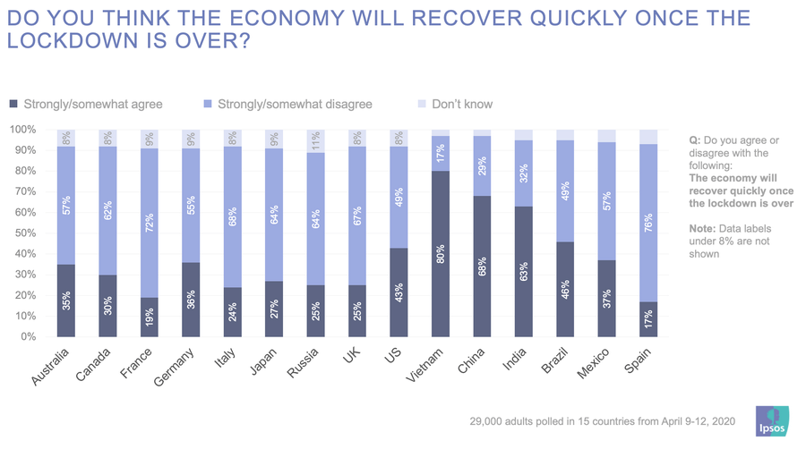People in Spain (76%), France (72%), Italy (68%), the United Kingdom (67%), Russia and Japan (64%), and Canada (62%) feel most strongly against a quick economic recovery in a survey of nearly 29,000 respondents conducted from April 9 to 12. Those in Vietnam (80%), China (68%) and India (63%) are most likely to say a quick recovery will take place.

At the same time, one of the countries most divided on this question is the world’s largest economy – the United States - with nearly half of those surveyed (49%) disagreeing on a quick recovery, while 43% think it will happen.

In terms of actions taken, majorities in India (56%), Brazil and Germany (54%) say all of the restrictions on travel and mandates for self-isolation will not stop the spread of COVID-19. That compares with majorities in China (63%), Australia (59%), Italy and Canada (58%), Spain (57%), the U.K., and Vietnam (54%) and France (51%) who think the restrictions do work.

Countries that have the seen the most significant change on this measure since mid-March are the ones where optimism has increased. Australia saw a drop of 17 percentage points in the number of those that agree the measures will not stop the spread of the pandemic, while the number of respondents in Japan fell by 13 points.

**References:**

**[1]. “‘A Brewing Storm’: Economic Impact of COVID-19 on Sri Lanka”,** [**Kithmina Hewage**](http://www.ips.lk/talkingeconomics/?author=54)

# [2]. “Public Opinion on the Covid-19 pandemic”, Ipsos experts